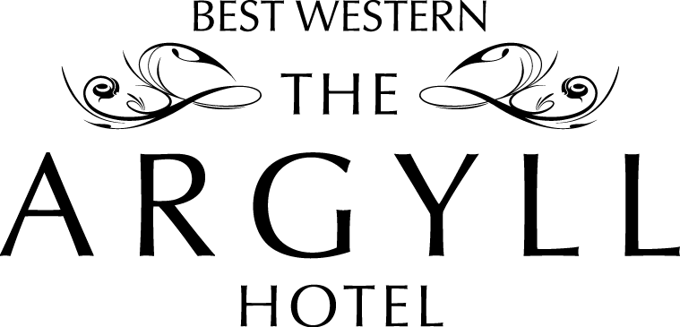
£9 .95 per person Please choose three main courses.

Breaded Haddock
Homemade Steak Pie
Gammon Steak
Ham Salad
All served with potatoes or chip and vegetables

**********
Tea Coffee
Cakes & Scones

