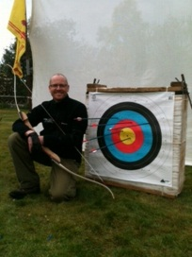
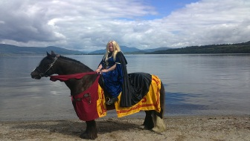
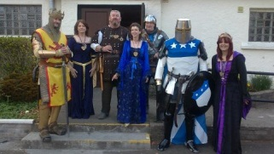
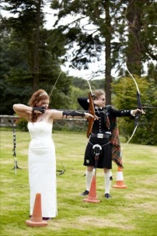
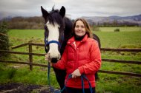
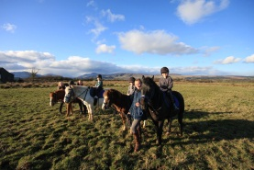
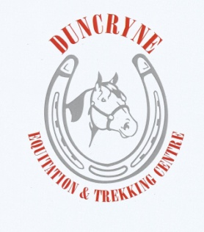
LOCH LOMOND’S VERY OWN
BRAVE CHALLENGE!!!!
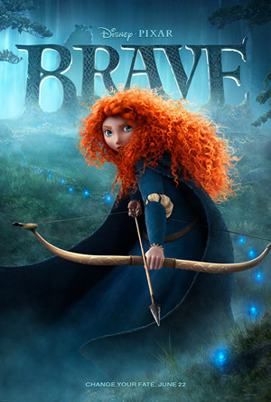
ON SELECTED DATES THROUGHOUT JULY AUGUST AND SEPTEMBER 10AM-4PM
FEEL LIKE YOUR OWN MOVIE STAR TAKING ON THE CHALLENGES OF THE BRAVE CHARACTERS…. RIDE INTO THE WILDERNESS ON HORSEBACK, PERFECT YOUR AIM WITH ARCHERY,BECOME A LEGEND WITH ROBERT THE BRUCE

TO CELEBRATE THE LAUNCH OF THE NEW DISNEY PIXAR MOVIE
DUNCRYNE EQUITATION AND TREKKING CENTRE IN GARTOCHARN IS HOSTING AND HAS TEAMED UP WITH LOMOND ARCHERS AND STRATHLEVEN ARTIZANS TO BRING YOU AN ADVENTURE NOT TO BE MISSED..
ARE YOU BRAVE ENOUGH TO TAKE ON THE CHALLENGE? CALL 01389830425 TO MAKE YOUR BOOKING or email d.e.t.c@hotmail.co.uk
RECEIVE YOUR VERY OWN BRAVERY CERTIFICATE WHEN YOU COMPLETE YOUR BRAVE CHALLENGES..
£60pp FOR A FULL DAY OF CHALLENGES
1 HOUR OF RIDING
1 HOUR OF ARCHERY
1 HOUR OF REAL SCOTTISH LEGEND “ROBERT THE BRUCE” ACTION
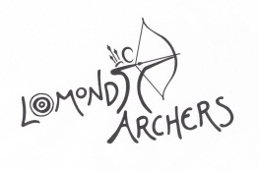
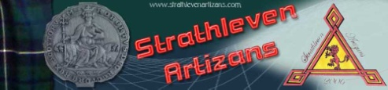
If you have enough energy after your challenge why not take an easy walk up the “dumpling hill” situated right next to our centre for spectacular views over Loch Lomond or take a short 40min drive to Stirling to experience the real Scottish traditions at Stirling castle…..

